Humus waste and energy management company (HW&EM) object to convert the organic waste into to energy and like to support farmer/country to move towards the organic farming by reducing dependence on chemical fertilizers.
To achieve our objective, we would to take a step and initiate a project to convert Kitchen waste (MSW waste) into Biogas and Compost
Project Overview
The proposed project involves the establishment of a Compressed Biogas (CBG) production facility utilizing kitchen waste/fruit-vegetable waste as the primary feedstock along with cattle manure. The project is being developed to convert MSW waste into renewable energy and organic fertilizers through anaerobic digestion technology and convert the slurry of digester into vermicompost/aerobic compost. The plant will produce high-quality Compressed Biogas (CBG) conforming to applicable industry standards and shall contribute towards sustainable waste management, renewable energy generation, reduction of greenhouse gas emissions, and promotion of circular economy principles.
The project has been conceptualized in line with the Government of India's initiatives for the promotion of biofuels and renewable energy under various programs aimed at reducing dependence on fossil fuels and enhancing energy security.
In addition to the production of CBG, the project will generate valuable by-products in the form of Solid Organic Fertilizer (SOF) and Liquid Fermented Organic Manure (LFOM), thereby creating multiple revenue streams while supporting sustainable agricultural practices.
The proposed facility will be developed with modern bio methanation and gas upgrading technology to ensure efficient utilization of feedstock, optimum methane recovery, and reliable plant operation.
Further strengthening the commercial viability of the project, a Bilateral Agreement is proposed to be entered into with Indraprastha Gas Limited (IGL) for the offtake and marketing of Compressed Biogas (CBG) under the applicable regulatory and commercial framework. The proposed agreement is expected to facilitate the sale and distribution of CBG produced by the plant through the IGL gas network, subject to applicable gas quality standards, pipeline connectivity requirements, and mutually agreed commercial terms. This arrangement is expected to enhance revenue certainty, mitigate market-related risks, and improve the overall bankability of the proposed project.

Renewing waste for clean energy.
The facility shall be designed for continuous operation throughout the year and will comprise segregated kitchen waste receiving and handling systems, pre-processing and feed preparation units, anaerobic digesters, biogas purification and upgrading systems, gas quality monitoring and metering equipment, and grid injection infrastructure. The upgraded biomethane shall be compressed or conditioned to meet the applicable gas quality, pressure, and safety requirements specified by Indraprastha Gas Limited (IGL) for injection into its gas network, subject to technical feasibility and necessary approvals. The facility will also include digestate handling and organic manure processing systems to ensure efficient resource recovery and environmentally sustainable waste management.
A 3.5 TPD CBG plant, Converting kitchen waste and cattle manure into Household stove Biogas for National Capital.
IGL retail grade 3.5 TPD biogas 180.46 MMBTU/DAY dispatched daily pipeline injection to Household stoves.
1277 T/YEAR anuual PNG production at design throughput
Project location
The proposed project is located in Ghitorni, New Delhi.
The project site has been strategically selected considering the availability of segregated kitchen waste and other biodegradable organic waste generated by bulk waste generators, including institutional kitchens, Army canteens, residential welfare associations (RWAs), hotels, restaurants, and other commercial establishments in the surrounding area. The site selection also considers transportation connectivity, water and power availability, waste collection logistics, and proximity to potential Compressed Biogas (CBG) offtake infrastructure. This approach is expected to facilitate reliable feedstock procurement through long-term waste supply agreements, optimize transportation costs, and ensure efficient and sustainable plant operations.
Technical requirements
The 4-acre land to segregate and process MSW waste into CGB.
- Segregation point - 2nd stage segregation of waste manual and by metal detector.
- Waster Shredder.
- Vertical Agitator mixing tank to mix organic waste with other carbon to maintain C:N ratio.
- Hydrolyzation tank or pre-digester may be provided upstream of the main anaerobic digester, subject to the selected process configuration
- Two Mesophilic anaerobic digestion each digester is designed with a diameter of 22 m and a cylindrical height of 9 m.
• Diameter: 22 m
• Cylindrical height: 9 m
• Gross volume: Approximately 3,421 m³
• Effective working volume (assumed 80%): Approximately 2,737 m³

- Two-stage hollow-fibre membrane Gas filters.
- Two gas holders, each having a storage capacity of 2,500 m³, in a total biogas storage capacity of 5,000 m³.
- Compressor
- SLS unit for Dewatering
- Compost making.

Potential feedstock Sources
The waste collection will be limit under 15 KM radius so that transportation cost and time duration can be reduced.
Source Category | Potential Feedstock
Hospitals, Institutional kitchens | Food preparation waste and plate waste
Residential welfare associations (RWAs) | Segregated household kitchen waste
Hotels and restaurants | Food scraps and biodegradable kitchen waste
Hostels and commercial establishments | Kitchen and catering waste
Other bulk waste generators | Segregated biodegradable organic waste
House hold Cattle and Gaushala | Cattle manure and urine
Other carbon Sources | Horticulture waste/farm waste

Summary
The proposed 3.5 TPD biomethane project represents an opportunity to integrate urban organic waste management with renewable energy generation. By utilizing segregated kitchen waste from bulk waste generators and supplying upgraded biomethane to the IGL city gas network, the project aims to support sustainable waste utilization, reduce dependence on conventional fossil fuels, and promote circular economy practices. Its ultimate technical and financial viability will depend on reliable feedstock supply, efficient plant operation, compliance with gas quality requirements, grid connectivity, and commercially viable offtake arrangements.
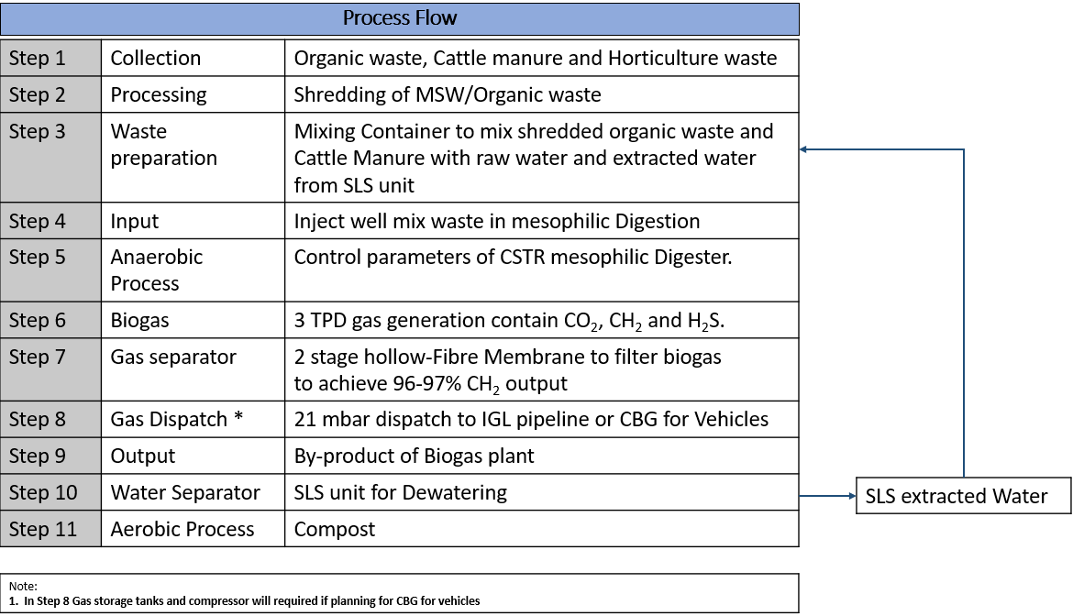

As per below chat we can understand by using a Food waste as a feedstock for Biogas digestor the out come will be very high (Biogas and Compost) in comparison with other sources.
